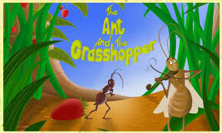
Once upon a time there was a grasshopper. It was summer time. Every day he was lying in the swing and was singing. One day, as he was resting and singing, he saw some ants working hard carrying seeds to their houses for the winter.
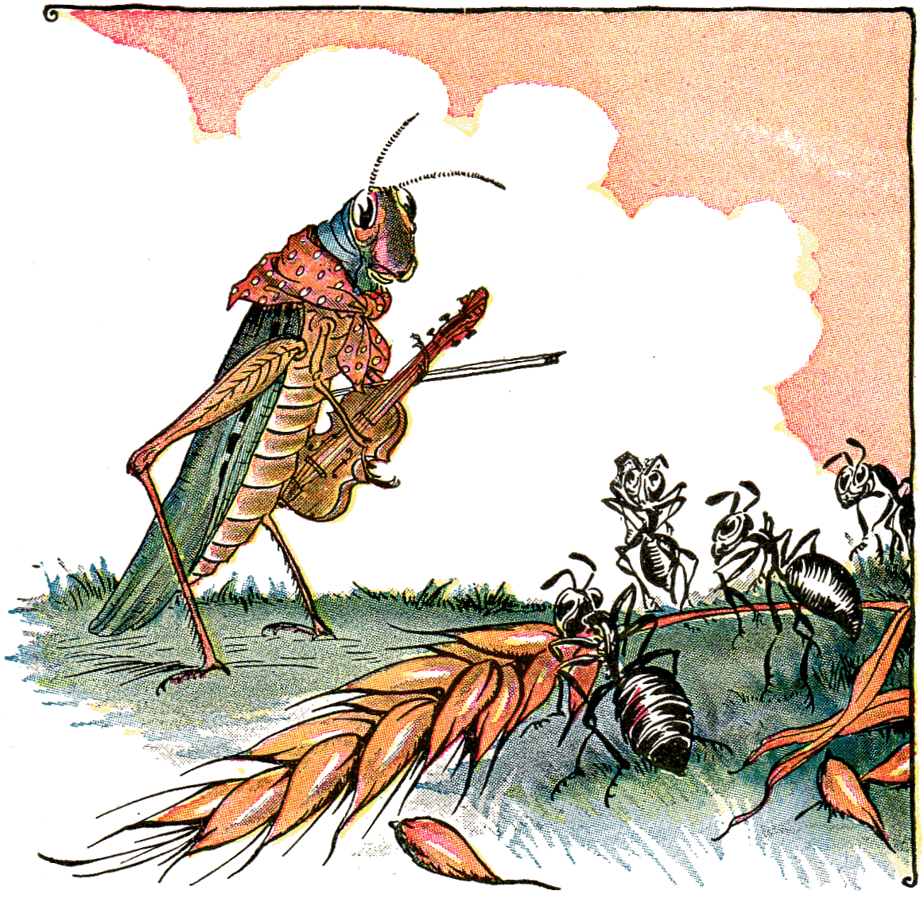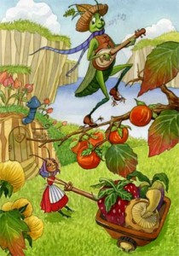

The grasshopper was so puzzled and asked them why they were working so hard instead of relaxing and enjoying the sun. The ants answered that they had to work hard because winter was near and if they did not want to starve they had to gather seeds…
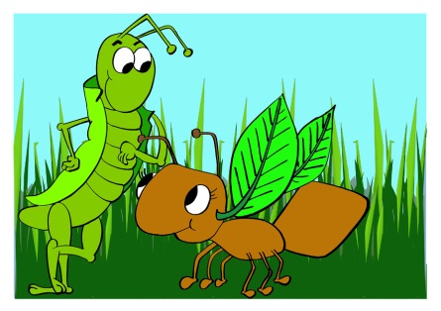
Sometime later winter arrived. One day the ants went out to play with the snow and saw the grasshopper under a big leaf trying to protect himself from the cold and snow. He was hungry and frozen to death! The nice ants carried the grasshopper to their house. It was warm and very comfortable. They put the grasshopper by the fire and offered him hot tea.
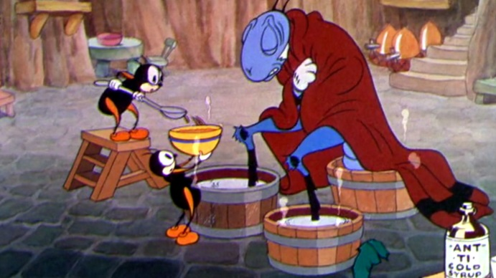
As the grasshopper was sitting by the fire an ant came close to him and said: “Do you remember? In summer you were laughing at me when I was saving food for the dark, cold days of the winter.”
The grasshopper knew that the ant was right and he would have died if the polite ants had not taken care of him!

THE END
CREATED BY THE 5TH GRADERS
EDITED BY THE 6TH GRADERS

