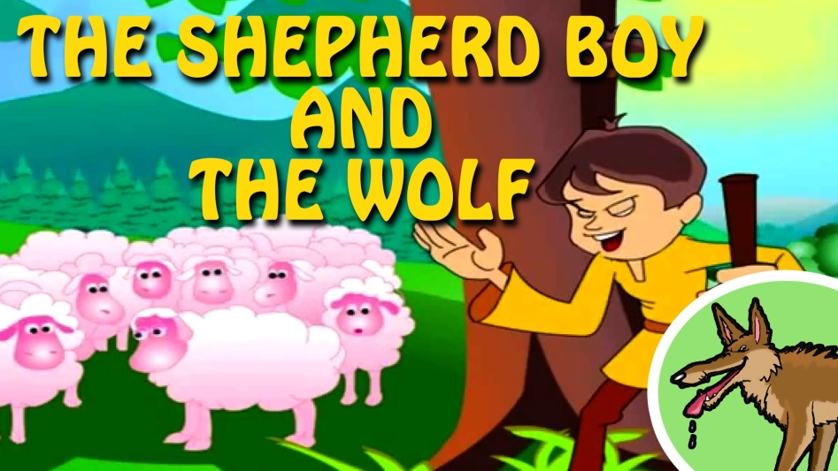
Once upon a time in a small village lived a young shepherd. One day, while he was sitting under a tree looking after his sheep, he got really bored. “I’m so bored and tired of doing the same things every day, I must do something! There is not a moment to lose”, he thought…
…and decided to play a trick on the villagers: he started shouting, “Help, help, a wolf, a wolf is attaching my sheep!!!!!”. The villagers ran quickly to the hill to find out what was going on. But when they arrived they did not see any wolf, only the young shepherd laughing and making fun of the anxious villagers.

Some days later the boy was bored again and thought of playing the same trick. He cried out that a wolf was attacking his sheep. In the beginning the villagers did not believe him, but the cries sounded so real that they ran to the hill once more. When they realized that the boy was telling lies again they shouted at him, “liar, liar” and left very angry!
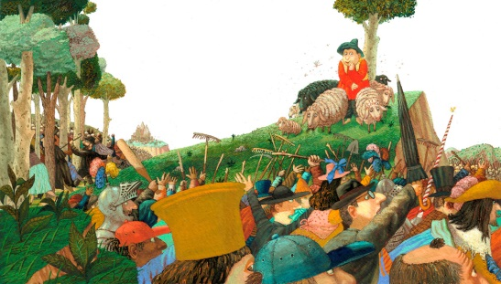
One day a real wolf attacked his sheep and ate them all!!!
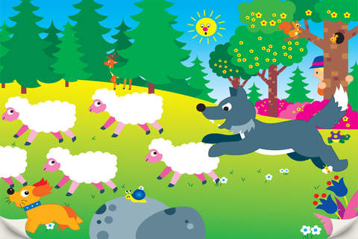
No matter how hard the young shepherd shouted, the villagers did not believe him. They thought he was playing a trick again! But this time they were wrong!
Well, whose fault was it? The shepherd’s of course! Don’t you agree?

THE END
CREATORS: 5th graders
EDITORS: 6th graders

