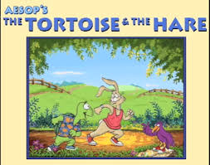
Once upon a time there was a Hare always boasting of his speed before the other animals. He kept saying that no one could run faster than him, no one can ever beat him! He was so arrogant and boastful that the other animals felt unhappy and angry!
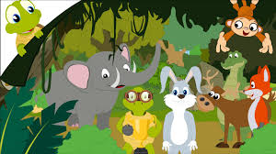
One day the Hare said, "I challenge any one here to race with me."
Among the animals that were listening to the Hare there was a Tortoise. The Tortoise thought about it for a moment and said quietly, "I accept your challenge!"
When the Hare heard the Tortoise started laughing and said sarcastically, "That is a good joke, I guess!"
The Tortoise did not mind his comment and told the Hare to keep his boasting until he has won, and asked him to race.
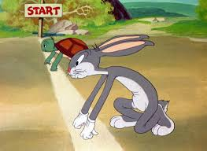
So a course was fixed and a start was made. The Hare ran almost out of sight at once…
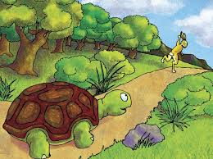
…but soon stopped and, to show his contempt for the Tortoise, lay down to have a nap.
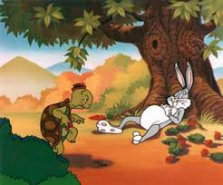
The Tortoise walked on and on steadily, and when the Hare woke up, he saw the Tortoise just near the winning-post! 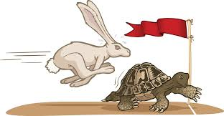

No matter how fast he ran he could not run up in time to save the race!
Then the Tortoise said: "Slow but steady progress wins the race."
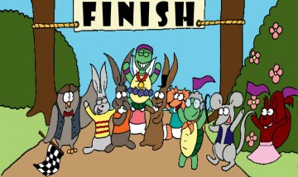

RETOLD BY THE 6TH GRADERS

