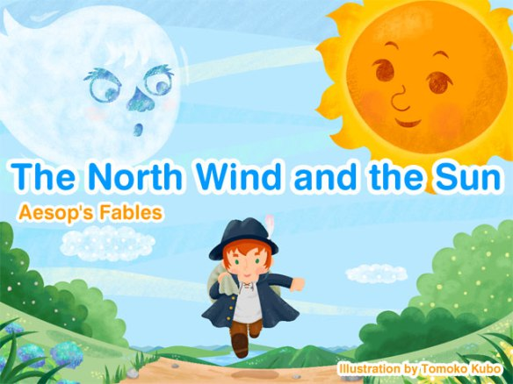
One day the Wind and the Sun were fighting about who was stronger.
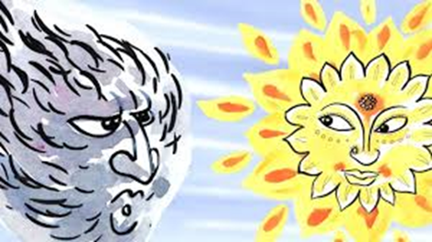
The wind said that he was stronger because he could uproot huge trees and overthrow ships and laughed at the Sun, “You can’t do either of these things” said the Wind. The Sun smiled and answered that this did not mean that the Wind was stronger.
The Wind got really angry. He believed he was more powerful than the Sun and he wanted to prove it! As they were arguing they saw a man walking on the road and they decided to challenge each other and see which one could remove the coat from the man's back the quickest.

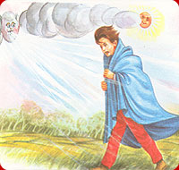
The Wind began. He blew so strongly that the man could barely walk… To protect himself from the wind and the cold he held his coat tight against him.
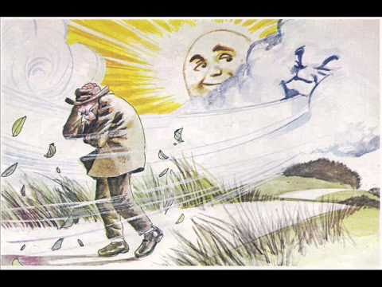
The wind blew harder and longer, and the harder the wind blew, the tighter the man held his coat against him.
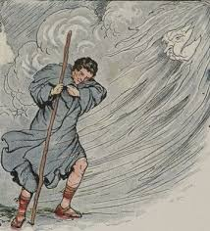
The wind got really exhausted and gave up blowing. To his disappointment, he saw it was impossible for him to remove the coat from the man's back.
It was now the Sun's turn. The Sun smiled kindly and he gently sent his beams on the traveler. At first nothing happened. The traveler went on walking with his coat on! Then the sun quietly shone upon his head and back until the man became so warm, actually hot, that he took off his coat and rushed to find a shady place, a tree, to protect himself from the heat.
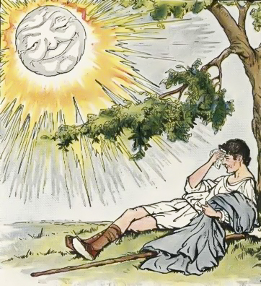
Moral: Always be kind and warm to others Or Gentle persuasion is stronger than force.

CREATED AND EDITED BY THE 6TH GRADERS

